alpha = 0.05

hate as offensive

input: mean of last 2 layers

adv: ffn

1 run...

training 1 epoch...

389.8044490814209 seconds used......

1 training finished! average train loss: 0.5979780583362816

total clf loss: 271.9175577610731 total adv loss: 140.26555172167718

evaluating...

Confusion matrix, without normalization

[[ 626 247 149]

[ 512 4772 123]

[1162 419 9184]]

Normalized confusion matrix

[[0.61252446 0.24168297 0.14579256]

[0.09469207 0.88255964 0.02274829]

[0.10794241 0.03892243 0.85313516]]

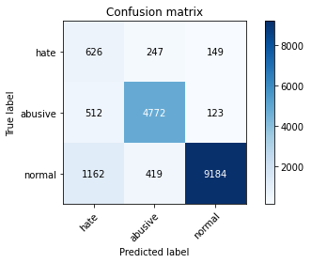

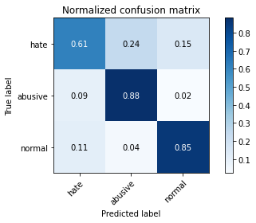

precision recall f1-score support

hate 0.27 0.61 0.38 1022

abusive 0.88 0.88 0.88 5407

normal 0.97 0.85 0.91 10765

accuracy 0.85 17194

macro avg 0.71 0.78 0.72 17194

weighted avg 0.90 0.85 0.87 17194

average eval_loss: 0.44690829211369504, accuracy: 0.8480865418169129

training 2 epoch...

389.8613166809082 seconds used......

2 training finished! average train loss: 0.43482263014561434

total clf loss: 197.4312384724617 total adv loss: 96.09626257512718

evaluating...

Confusion matrix, without normalization

[[ 652 211 159]

[ 646 4616 145]

[1021 352 9392]]

Normalized confusion matrix

[[0.63796477 0.20645793 0.1555773 ]

[0.11947475 0.85370816 0.02681709]

[0.0948444 0.03269856 0.87245704]]

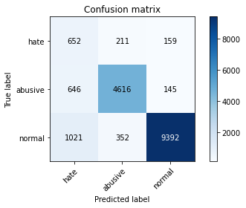

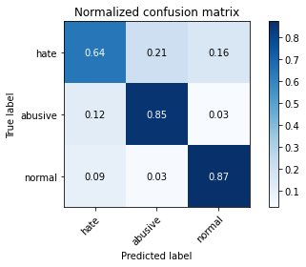

precision recall f1-score support

hate 0.28 0.64 0.39 1022

abusive 0.89 0.85 0.87 5407

normal 0.97 0.87 0.92 10765

accuracy 0.85 17194

macro avg 0.71 0.79 0.73 17194

weighted avg 0.90 0.85 0.87 17194

average eval_loss: 0.41248342938028104, accuracy: 0.8526230080260556

training 3 epoch...

389.6177124977112 seconds used......

3 training finished! average train loss: 0.32551643552582366

total clf loss: 147.48512420803308 total adv loss: 65.62686257483438

evaluating...

Confusion matrix, without normalization

[[ 735 160 127]

[1165 4130 112]

[1671 313 8781]]

Normalized confusion matrix

[[0.71917808 0.15655577 0.12426614]

[0.21546144 0.76382467 0.02071389]

[0.15522527 0.02907571 0.81569902]]

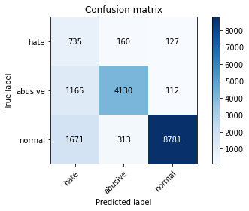

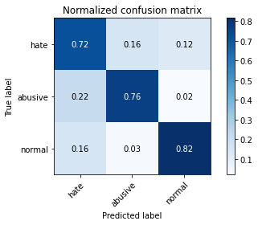

precision recall f1-score support

hate 0.21 0.72 0.32 1022

abusive 0.90 0.76 0.83 5407

normal 0.97 0.82 0.89 10765

accuracy 0.79 17194

macro avg 0.69 0.77 0.68 17194

weighted avg 0.90 0.79 0.83 17194

average eval_loss: 0.6126614012863747, accuracy: 0.7936489473072001

training 4 epoch...

389.93707942962646 seconds used......

4 training finished! average train loss: 0.21582150286059348

total clf loss: 97.59860747121274 total adv loss: 39.79363667615689

evaluating...

Confusion matrix, without normalization

[[ 657 236 129]

[ 631 4637 139]

[1599 386 8780]]

Normalized confusion matrix

[[0.64285714 0.23091977 0.12622309]

[0.11670057 0.85759201 0.02570742]

[0.14853693 0.03585694 0.81560613]]

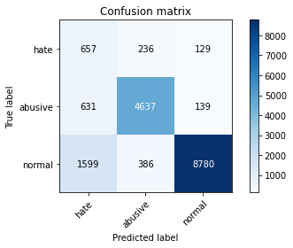

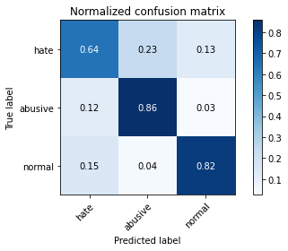

precision recall f1-score support

hate 0.23 0.64 0.34 1022

abusive 0.88 0.86 0.87 5407

normal 0.97 0.82 0.89 10765

accuracy 0.82 17194

macro avg 0.69 0.77 0.70 17194

weighted avg 0.90 0.82 0.85 17194

average eval_loss: 0.649582315253657, accuracy: 0.818541351634291

training 5 epoch...

389.67549180984497 seconds used......

5 training finished! average train loss: 0.1471478967374489

total clf loss: 66.4478571889922 total adv loss: 25.2267762569536

evaluating...

Confusion matrix, without normalization

[[ 674 210 138]

[ 933 4337 137]

[1763 350 8652]]

Normalized confusion matrix

[[0.65949119 0.20547945 0.13502935]

[0.1725541 0.80210838 0.02533753]

[0.16377148 0.03251277 0.80371575]]

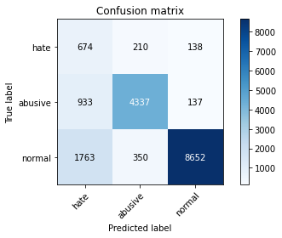

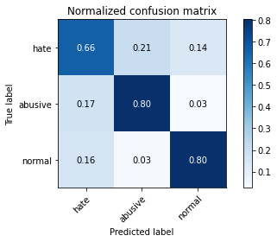

precision recall f1-score support

hate 0.20 0.66 0.31 1022

abusive 0.89 0.80 0.84 5407

normal 0.97 0.80 0.88 10765

accuracy 0.79 17194

macro avg 0.68 0.76 0.68 17194

weighted avg 0.90 0.79 0.83 17194

average eval_loss: 0.7991963084375616, accuracy: 0.7946376643015005

training 6 epoch...

389.8042211532593 seconds used......

6 training finished! average train loss: 0.10251126460979101

total clf loss: 46.242873209994286 total adv loss: 16.60765980037104

evaluating...

Confusion matrix, without normalization

[[ 685 191 146]

[1124 4144 139]

[1445 365 8955]]

Normalized confusion matrix

[[0.6702544 0.18688845 0.14285714]

[0.20787868 0.76641391 0.02570742]

[0.13423131 0.03390618 0.83186252]]

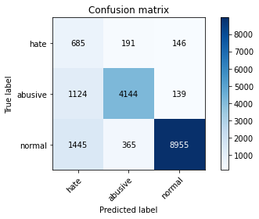

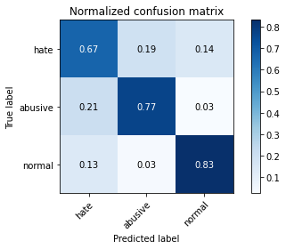

precision recall f1-score support

hate 0.21 0.67 0.32 1022

abusive 0.88 0.77 0.82 5407

normal 0.97 0.83 0.90 10765

accuracy 0.80 17194

macro avg 0.69 0.76 0.68 17194

weighted avg 0.90 0.80 0.84 17194

average eval_loss: 0.8117739314083443, accuracy: 0.8016750029079912

training 7 epoch...

389.80073261260986 seconds used......

7 training finished! average train loss: 0.0802004775287306

total clf loss: 36.16281897109002 total adv loss: 12.680147149483673

evaluating...

Confusion matrix, without normalization

[[ 696 165 161]

[1121 4095 191]

[1385 279 9101]]

Normalized confusion matrix

[[0.68101761 0.16144814 0.15753425]

[0.20732384 0.75735158 0.03532458]

[0.12865769 0.02591732 0.84542499]]

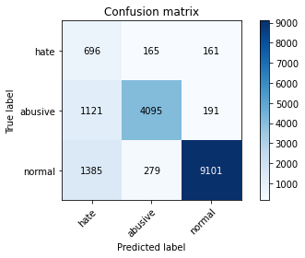

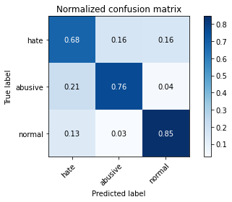

precision recall f1-score support

hate 0.22 0.68 0.33 1022

abusive 0.90 0.76 0.82 5407

normal 0.96 0.85 0.90 10765

accuracy 0.81 17194

macro avg 0.69 0.76 0.68 17194

weighted avg 0.90 0.81 0.84 17194

average eval_loss: 0.9006243427457331, accuracy: 0.807956263812958

training 8 epoch...

389.6174364089966 seconds used......

8 training finished! average train loss: 0.0788349169878022

total clf loss: 35.61341214738786 total adv loss: 13.790878403644456

evaluating...

Confusion matrix, without normalization

[[ 674 255 93]

[ 861 4464 82]

[2387 689 7689]]

Normalized confusion matrix

[[0.65949119 0.24951076 0.09099804]

[0.15923802 0.82559645 0.01516553]

[0.22173711 0.06400372 0.71425917]]

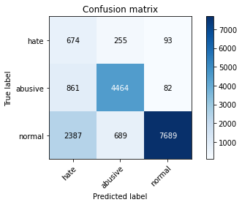

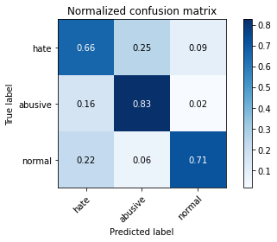

precision recall f1-score support

hate 0.17 0.66 0.27 1022

abusive 0.83 0.83 0.83 5407

normal 0.98 0.71 0.83 10765

accuracy 0.75 17194

macro avg 0.66 0.73 0.64 17194

weighted avg 0.88 0.75 0.79 17194

average eval_loss: 1.1422582207550835, accuracy: 0.7460160521112016

training 9 epoch...

389.4009301662445 seconds used......

9 training finished! average train loss: 0.06484209229138471

total clf loss: 29.26292670238763 total adv loss: 10.757598848365888

evaluating...

Confusion matrix, without normalization

[[ 649 160 213]

[1058 4115 234]

[ 922 266 9577]]

Normalized confusion matrix

[[0.63502935 0.15655577 0.20841487]

[0.19567228 0.76105049 0.04327723]

[0.08564793 0.02470971 0.88964236]]

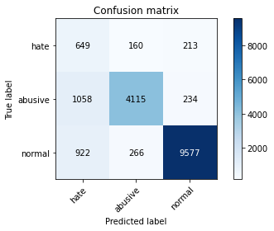

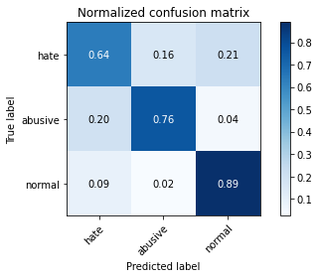

precision recall f1-score support

hate 0.25 0.64 0.36 1022

abusive 0.91 0.76 0.83 5407

normal 0.96 0.89 0.92 10765

accuracy 0.83 17194

macro avg 0.70 0.76 0.70 17194

weighted avg 0.90 0.83 0.86 17194

average eval_loss: 0.8242017169688763, accuracy: 0.8340700244271257

training 10 epoch...

389.48812460899353 seconds used......

10 training finished! average train loss: 0.06357460023837141

total clf loss: 28.629597611434292 total adv loss: 9.320992667293467

evaluating...

Confusion matrix, without normalization

[[ 619 253 150]

[ 732 4507 168]

[1355 439 8971]]

Normalized confusion matrix

[[0.60567515 0.24755382 0.14677104]

[0.13538006 0.8335491 0.03107083]

[0.12587088 0.04078031 0.83334882]]

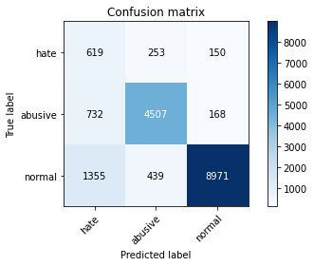

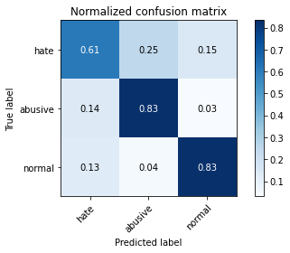

precision recall f1-score support

hate 0.23 0.61 0.33 1022

abusive 0.87 0.83 0.85 5407

normal 0.97 0.83 0.89 10765

accuracy 0.82 17194

macro avg 0.69 0.76 0.69 17194

weighted avg 0.89 0.82 0.85 17194

average eval_loss: 0.8752562655964433, accuracy: 0.8198790275677562

2 run...

training 1 epoch...

388.9851973056793 seconds used......

1 training finished! average train loss: 0.5740528544642317

total clf loss: 261.2202380746603 total adv loss: 138.2964648362249

evaluating...

Confusion matrix, without normalization

[[ 676 159 187]

[ 910 4336 161]

[ 858 326 9581]]

Normalized confusion matrix

[[0.66144814 0.1555773 0.18297456]

[0.16830035 0.80192343 0.02977622]

[0.07970274 0.03028333 0.89001393]]

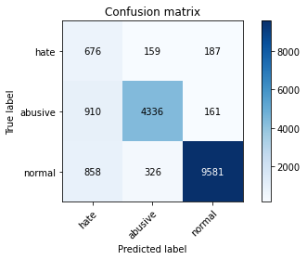

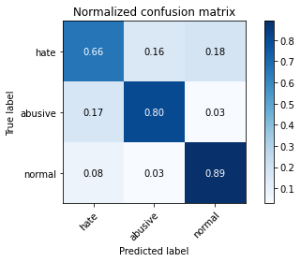

precision recall f1-score support

hate 0.28 0.66 0.39 1022

abusive 0.90 0.80 0.85 5407

normal 0.96 0.89 0.93 10765

accuracy 0.85 17194

macro avg 0.71 0.78 0.72 17194

weighted avg 0.90 0.85 0.87 17194

average eval_loss: 0.4301525462851968, accuracy: 0.8487262998720484

training 2 epoch...

389.16037106513977 seconds used......

2 training finished! average train loss: 0.4308984675707451

total clf loss: 195.66645666956902 total adv loss: 95.56871463730931

evaluating...

Confusion matrix, without normalization

[[ 720 193 109]

[ 815 4514 78]

[1962 364 8439]]

Normalized confusion matrix

[[0.70450098 0.1888454 0.10665362]

[0.15073053 0.83484372 0.01442574]

[0.18225732 0.03381328 0.7839294 ]]

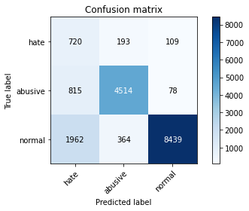

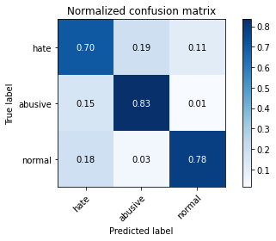

precision recall f1-score support

hate 0.21 0.70 0.32 1022

abusive 0.89 0.83 0.86 5407

normal 0.98 0.78 0.87 10765

accuracy 0.80 17194

macro avg 0.69 0.77 0.68 17194

weighted avg 0.90 0.80 0.83 17194

average eval_loss: 0.5868066869676113, accuracy: 0.7952192625334419

training 3 epoch...

389.21338295936584 seconds used......

3 training finished! average train loss: 0.31875318108004586

total clf loss: 144.4938557203859 total adv loss: 65.72393497731537

evaluating...

Confusion matrix, without normalization

[[ 751 150 121]

[1142 4141 124]

[1938 262 8565]]

Normalized confusion matrix

[[0.73483366 0.14677104 0.1183953 ]

[0.21120769 0.76585907 0.02293323]

[0.18002787 0.02433813 0.795634 ]]

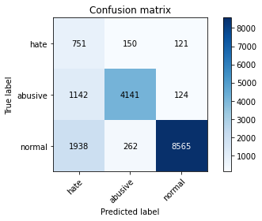

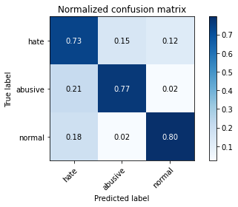

precision recall f1-score support

hate 0.20 0.73 0.31 1022

abusive 0.91 0.77 0.83 5407

normal 0.97 0.80 0.88 10765

accuracy 0.78 17194

macro avg 0.69 0.77 0.67 17194

weighted avg 0.91 0.78 0.83 17194

average eval_loss: 0.6399012163281441, accuracy: 0.7826567407235082

training 4 epoch...

389.00296807289124 seconds used......

4 training finished! average train loss: 0.21698236060549525

total clf loss: 97.95229817740619 total adv loss: 36.58224653801881

evaluating...

Confusion matrix, without normalization

[[ 715 152 155]

[1131 4113 163]

[1293 281 9191]]

Normalized confusion matrix

[[0.69960861 0.14872798 0.15166341]

[0.20917329 0.7606806 0.03014611]

[0.12011147 0.02610311 0.85378542]]

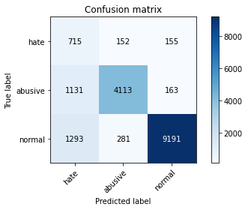

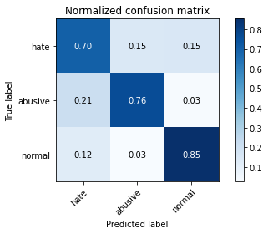

precision recall f1-score support

hate 0.23 0.70 0.34 1022

abusive 0.90 0.76 0.83 5407

normal 0.97 0.85 0.91 10765

accuracy 0.82 17194

macro avg 0.70 0.77 0.69 17194

weighted avg 0.90 0.82 0.85 17194

average eval_loss: 0.6028592905701073, accuracy: 0.8153425613586135

training 5 epoch...

389.46013379096985 seconds used......

5 training finished! average train loss: 0.1424507482595422

total clf loss: 64.25611682701856 total adv loss: 23.008705983578693

evaluating...

Confusion matrix, without normalization

[[ 696 185 141]

[1041 4252 114]

[1661 347 8757]]

Normalized confusion matrix

[[0.68101761 0.18101761 0.13796477]

[0.1925282 0.78638802 0.02108378]

[0.15429633 0.03223409 0.81346958]]

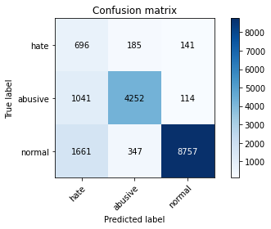

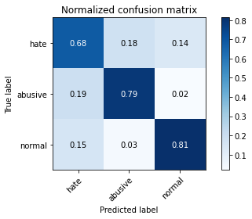

precision recall f1-score support

hate 0.20 0.68 0.31 1022

abusive 0.89 0.79 0.83 5407

normal 0.97 0.81 0.89 10765

accuracy 0.80 17194

macro avg 0.69 0.76 0.68 17194

weighted avg 0.90 0.80 0.84 17194

average eval_loss: 0.7975970951970234, accuracy: 0.7970803768756543

training 6 epoch...

389.6960141658783 seconds used......

6 training finished! average train loss: 0.10222911093232662

total clf loss: 46.00469083013013 total adv loss: 14.343894626974361

evaluating...

Confusion matrix, without normalization

[[ 654 208 160]

[ 879 4327 201]

[1263 329 9173]]

Normalized confusion matrix

[[0.63992172 0.2035225 0.15655577]

[0.16256704 0.80025892 0.03717403]

[0.11732466 0.03056201 0.85211333]]

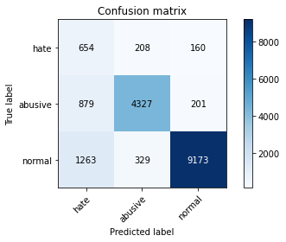

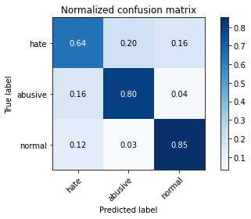

precision recall f1-score support

hate 0.23 0.64 0.34 1022

abusive 0.89 0.80 0.84 5407

normal 0.96 0.85 0.90 10765

accuracy 0.82 17194

macro avg 0.70 0.76 0.70 17194

weighted avg 0.90 0.82 0.85 17194

average eval_loss: 0.7708826244754586, accuracy: 0.8231941374898221

training 7 epoch...

389.5835540294647 seconds used......

7 training finished! average train loss: 0.08416003608207889

total clf loss: 37.944755801931024 total adv loss: 13.23719741509558

evaluating...

Confusion matrix, without normalization

[[ 659 196 167]

[ 942 4274 191]

[1258 344 9163]]

Normalized confusion matrix

[[0.64481409 0.19178082 0.16340509]

[0.17421861 0.79045682 0.03532458]

[0.1168602 0.03195541 0.85118439]]

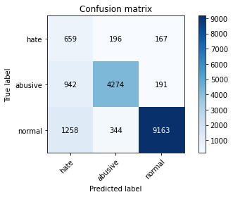

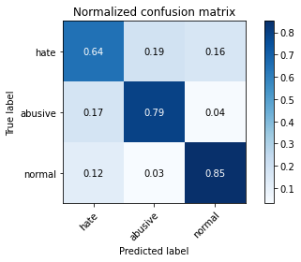

precision recall f1-score support

hate 0.23 0.64 0.34 1022

abusive 0.89 0.79 0.84 5407

normal 0.96 0.85 0.90 10765

accuracy 0.82 17194

macro avg 0.69 0.76 0.69 17194

weighted avg 0.90 0.82 0.85 17194

average eval_loss: 0.8071770509542507, accuracy: 0.8198208677445621

training 8 epoch...

389.66901326179504 seconds used......

8 training finished! average train loss: 0.0704134227433368

total clf loss: 31.667756266193464 total adv loss: 9.49219954063301

evaluating...

Confusion matrix, without normalization

[[ 614 240 168]

[ 752 4454 201]

[1125 373 9267]]

Normalized confusion matrix

[[0.60078278 0.23483366 0.16438356]

[0.13907897 0.82374699 0.03717403]

[0.10450534 0.03464933 0.86084533]]

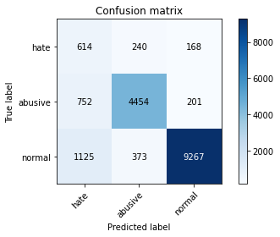

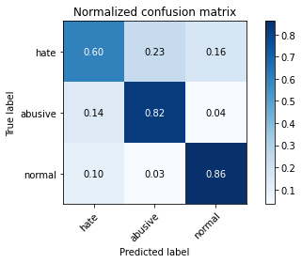

precision recall f1-score support

hate 0.25 0.60 0.35 1022

abusive 0.88 0.82 0.85 5407

normal 0.96 0.86 0.91 10765

accuracy 0.83 17194

macro avg 0.70 0.76 0.70 17194

weighted avg 0.89 0.83 0.86 17194

average eval_loss: 0.8529917778454039, accuracy: 0.8337210654879609

training 9 epoch...

389.99299669265747 seconds used......

9 training finished! average train loss: 0.06923883022797246

total clf loss: 31.212014509656 total adv loss: 10.784254890571901

evaluating...

Confusion matrix, without normalization

[[ 587 232 203]

[ 687 4476 244]

[ 989 316 9460]]

Normalized confusion matrix

[[0.57436399 0.22700587 0.19863014]

[0.12705752 0.82781579 0.04512669]

[0.09187181 0.02935439 0.8787738 ]]

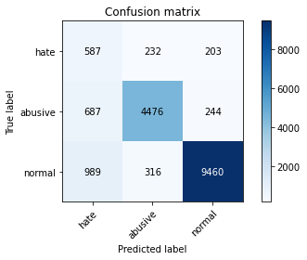

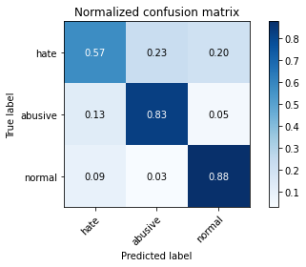

precision recall f1-score support

hate 0.26 0.57 0.36 1022

abusive 0.89 0.83 0.86 5407

normal 0.95 0.88 0.92 10765

accuracy 0.84 17194

macro avg 0.70 0.76 0.71 17194

weighted avg 0.89 0.84 0.86 17194

average eval_loss: 0.7749682310018363, accuracy: 0.8446551122484588

training 10 epoch...

389.8584635257721 seconds used......

10 training finished! average train loss: 0.06130422696218412

total clf loss: 27.541257114091422 total adv loss: 7.6696925572332475

evaluating...

Confusion matrix, without normalization

[[ 667 192 163]

[ 982 4232 193]

[1284 320 9161]]

Normalized confusion matrix

[[0.65264188 0.18786693 0.15949119]

[0.18161642 0.78268911 0.03569447]

[0.11927543 0.02972596 0.85099861]]

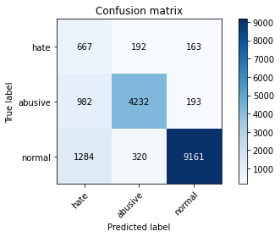

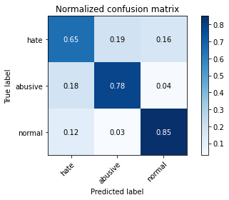

precision recall f1-score support

hate 0.23 0.65 0.34 1022

abusive 0.89 0.78 0.83 5407

normal 0.96 0.85 0.90 10765

accuracy 0.82 17194

macro avg 0.69 0.76 0.69 17194

weighted avg 0.90 0.82 0.85 17194

average eval_loss: 0.9879773135401233, accuracy: 0.8177271141095731

3 run...

training 1 epoch...

389.53370571136475 seconds used......

1 training finished! average train loss: 0.6060660585727433

total clf loss: 275.7671617567539 total adv loss: 145.5979689285159

evaluating...

Confusion matrix, without normalization

[[ 671 168 183]

[ 810 4425 172]

[ 819 296 9650]]

Normalized confusion matrix

[[0.65655577 0.16438356 0.17906067]

[0.14980581 0.81838358 0.03181062]

[0.07607989 0.02749652 0.89642359]]

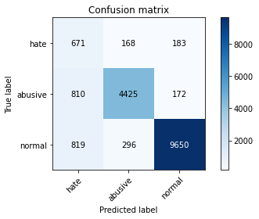

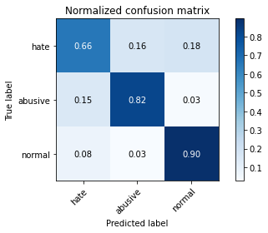

precision recall f1-score support

hate 0.29 0.66 0.40 1022

abusive 0.91 0.82 0.86 5407

normal 0.96 0.90 0.93 10765

accuracy 0.86 17194

macro avg 0.72 0.79 0.73 17194

weighted avg 0.91 0.86 0.88 17194

average eval_loss: 0.4101873133158268, accuracy: 0.8576247528207515

training 2 epoch...

389.53902864456177 seconds used......

2 training finished! average train loss: 0.4439182475242873

total clf loss: 201.53364987671375 total adv loss: 97.55732817389071

evaluating...

Confusion matrix, without normalization

[[ 674 196 152]

[ 794 4483 130]

[1026 430 9309]]

Normalized confusion matrix

[[0.65949119 0.19178082 0.14872798]

[0.14684668 0.82911041 0.02404291]

[0.09530887 0.03994426 0.86474686]]

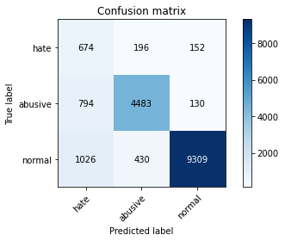

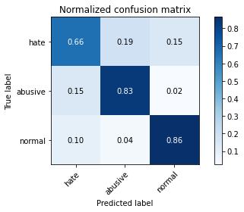

precision recall f1-score support

hate 0.27 0.66 0.38 1022

abusive 0.88 0.83 0.85 5407

normal 0.97 0.86 0.91 10765

accuracy 0.84 17194

macro avg 0.71 0.78 0.72 17194

weighted avg 0.90 0.84 0.86 17194

average eval_loss: 0.44998827471809333, accuracy: 0.8413400023263929

training 3 epoch...

389.59316754341125 seconds used......

3 training finished! average train loss: 0.33092052080830386

total clf loss: 149.89681370556355 total adv loss: 65.98045549262315

evaluating...

Confusion matrix, without normalization

[[ 712 175 135]

[ 966 4311 130]

[1534 315 8916]]

Normalized confusion matrix

[[0.69667319 0.17123288 0.13209393]

[0.1786573 0.7972998 0.02404291]

[0.14249884 0.0292615 0.82823967]]

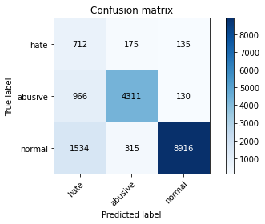

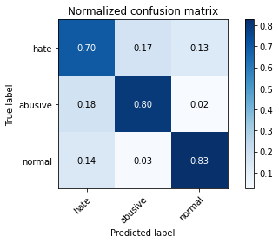

precision recall f1-score support

hate 0.22 0.70 0.34 1022

abusive 0.90 0.80 0.84 5407

normal 0.97 0.83 0.89 10765

accuracy 0.81 17194

macro avg 0.70 0.77 0.69 17194

weighted avg 0.90 0.81 0.85 17194

average eval_loss: 0.5803969958060703, accuracy: 0.8106897755030825

training 4 epoch...

389.56806659698486 seconds used......

4 training finished! average train loss: 0.22716057218157143

total clf loss: 102.62049227021635 total adv loss: 39.767178698210046

evaluating...

Confusion matrix, without normalization

[[ 673 176 173]

[ 930 4322 155]

[1360 278 9127]]

Normalized confusion matrix

[[0.65851272 0.17221135 0.16927593]

[0.17199926 0.7993342 0.02866654]

[0.12633535 0.02582443 0.84784022]]

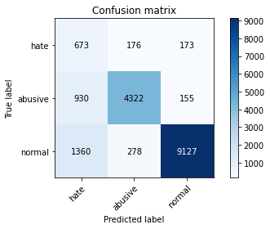

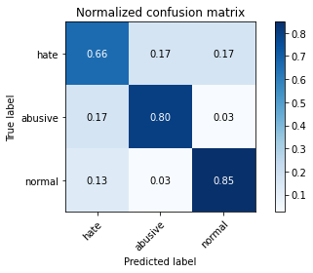

precision recall f1-score support

hate 0.23 0.66 0.34 1022

abusive 0.90 0.80 0.85 5407

normal 0.97 0.85 0.90 10765

accuracy 0.82 17194

macro avg 0.70 0.77 0.70 17194

weighted avg 0.90 0.82 0.85 17194

average eval_loss: 0.6466020282271296, accuracy: 0.8213330231476096

training 5 epoch...

389.36897587776184 seconds used......

5 training finished! average train loss: 0.15315752644217984

total clf loss: 69.10360307712108 total adv loss: 25.096381148905493

evaluating...

Confusion matrix, without normalization

[[ 626 275 121]

[ 660 4631 116]

[1864 476 8425]]

Normalized confusion matrix

[[0.61252446 0.26908023 0.1183953 ]

[0.12206399 0.85648234 0.02145367]

[0.17315374 0.04421737 0.78262889]]

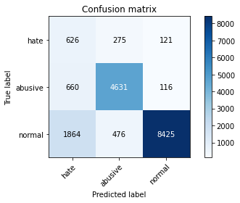

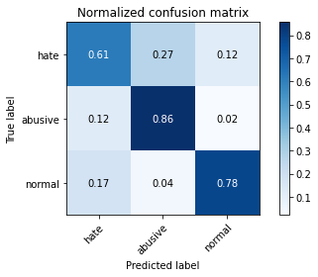

precision recall f1-score support

hate 0.20 0.61 0.30 1022

abusive 0.86 0.86 0.86 5407

normal 0.97 0.78 0.87 10765

accuracy 0.80 17194

macro avg 0.68 0.75 0.68 17194

weighted avg 0.89 0.80 0.83 17194

average eval_loss: 0.7932793817937721, accuracy: 0.7957427009421891

training 6 epoch...

389.59437823295593 seconds used......

6 training finished! average train loss: 0.10457127981842337

total clf loss: 47.0639658421278 total adv loss: 14.777778542265878

evaluating...

Confusion matrix, without normalization

[[ 668 193 161]

[1081 4174 152]

[1479 395 8891]]

Normalized confusion matrix

[[0.65362035 0.1888454 0.15753425]

[0.19992602 0.77196227 0.02811171]

[0.13738969 0.03669299 0.82591732]]

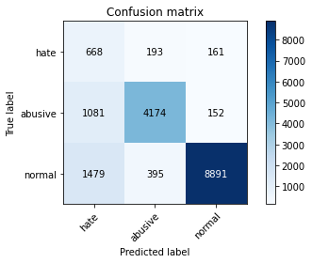

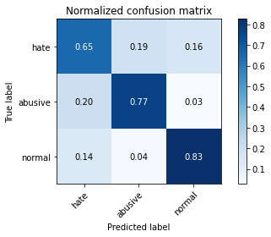

precision recall f1-score support

hate 0.21 0.65 0.31 1022

abusive 0.88 0.77 0.82 5407

normal 0.97 0.83 0.89 10765

accuracy 0.80 17194

macro avg 0.68 0.75 0.68 17194

weighted avg 0.89 0.80 0.83 17194

average eval_loss: 0.801166397806387, accuracy: 0.7987088519250901

training 7 epoch...

389.4225091934204 seconds used......

7 training finished! average train loss: 0.07940919689716389

total clf loss: 35.639859255519696 total adv loss: 9.231702374629094

evaluating...

Confusion matrix, without normalization

[[ 691 178 153]

[1079 4151 177]

[1415 307 9043]]

Normalized confusion matrix

[[0.67612524 0.1741683 0.14970646]

[0.19955613 0.76770853 0.03273534]

[0.1314445 0.02851835 0.84003716]]

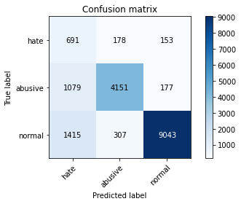

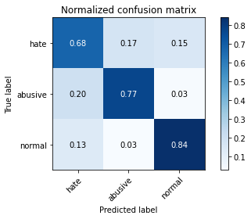

precision recall f1-score support

hate 0.22 0.68 0.33 1022

abusive 0.90 0.77 0.83 5407

normal 0.96 0.84 0.90 10765

accuracy 0.81 17194

macro avg 0.69 0.76 0.68 17194

weighted avg 0.90 0.81 0.84 17194

average eval_loss: 0.9397918646456673, accuracy: 0.807549145050599

training 8 epoch...

3 run...

Downloading: 100%

411/411 [00:00<00:00, 10.1kB/s]

Downloading: 100%

263M/263M [00:10<00:00, 30.0MB/s]

training 1 epoch...

395.3764228820801 seconds used......

1 training finished! average train loss: 0.5912865547644096

total clf loss: 269.04229013621807 total adv loss: 142.04692381247878

evaluating...

Confusion matrix, without normalization

[[ 662 236 124]

[ 584 4714 109]

[1459 413 8893]]

Normalized confusion matrix

[[0.64774951 0.23091977 0.12133072]

[0.10800814 0.87183281 0.02015905]

[0.13553182 0.03836507 0.82610311]]

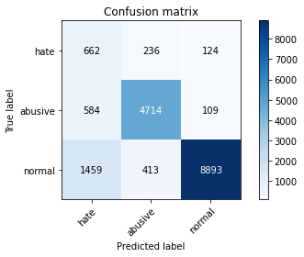

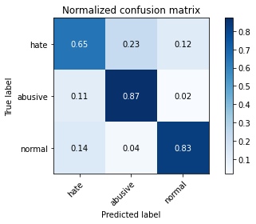

precision recall f1-score support

hate 0.24 0.65 0.36 1022

abusive 0.88 0.87 0.88 5407

normal 0.97 0.83 0.89 10765

accuracy 0.83 17194

macro avg 0.70 0.78 0.71 17194

weighted avg 0.90 0.83 0.86 17194

average eval_loss: 0.4845140168140101, accuracy: 0.8298825171571479

training 2 epoch...

395.0372562408447 seconds used......

2 training finished! average train loss: 0.43413062348255455

total clf loss: 197.1937930136919 total adv loss: 97.4785365536809

evaluating...

Confusion matrix, without normalization

[[ 661 188 173]

[ 820 4433 154]

[ 893 322 9550]]

Normalized confusion matrix

[[0.64677104 0.18395303 0.16927593]

[0.15165526 0.81986314 0.0284816 ]

[0.08295402 0.02991175 0.88713423]]

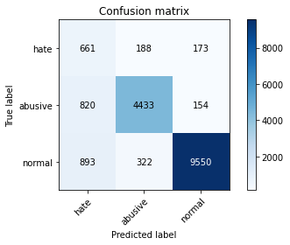

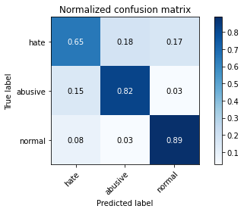

precision recall f1-score support

hate 0.28 0.65 0.39 1022

abusive 0.90 0.82 0.86 5407

normal 0.97 0.89 0.93 10765

accuracy 0.85 17194

macro avg 0.71 0.78 0.72 17194

weighted avg 0.90 0.85 0.87 17194

average eval_loss: 0.39556782225710013, accuracy: 0.8516924508549494

training 3 epoch...

395.09405732154846 seconds used......

3 training finished! average train loss: 0.32585019514839214

total clf loss: 147.66099188104272 total adv loss: 66.18711335677654

evaluating...

Confusion matrix, without normalization

[[ 648 192 182]

[ 772 4461 174]

[ 999 321 9445]]

Normalized confusion matrix

[[0.63405088 0.18786693 0.17808219]

[0.14277788 0.82504161 0.03218051]

[0.09280074 0.02981886 0.8773804 ]]

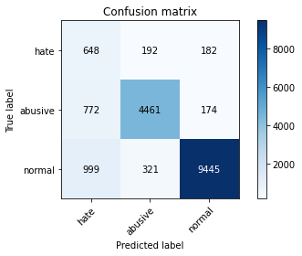

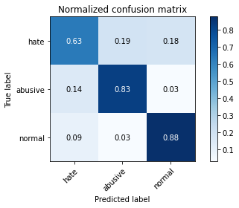

precision recall f1-score support

hate 0.27 0.63 0.38 1022

abusive 0.90 0.83 0.86 5407

normal 0.96 0.88 0.92 10765

accuracy 0.85 17194

macro avg 0.71 0.78 0.72 17194

weighted avg 0.90 0.85 0.87 17194

average eval_loss: 0.44095843490213155, accuracy: 0.846458066767477

training 4 epoch...

395.25082325935364 seconds used......

4 training finished! average train loss: 0.21506991072370762

total clf loss: 97.09947519935668 total adv loss: 36.470096998033114

evaluating...

Confusion matrix, without normalization

[[ 753 144 125]

[1308 3980 119]

[1753 310 8702]]

Normalized confusion matrix

[[0.73679061 0.1409002 0.1223092 ]

[0.24190864 0.73608286 0.02200851]

[0.16284255 0.02879703 0.80836043]]

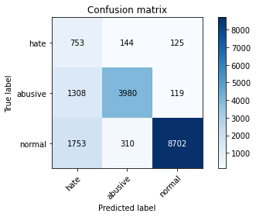

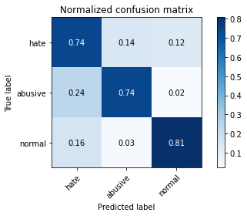

precision recall f1-score support

hate 0.20 0.74 0.31 1022

abusive 0.90 0.74 0.81 5407

normal 0.97 0.81 0.88 10765

accuracy 0.78 17194

macro avg 0.69 0.76 0.67 17194

weighted avg 0.90 0.78 0.83 17194

average eval_loss: 0.7219630665297425, accuracy: 0.7813772246132372

training 5 epoch...

395.96933674812317 seconds used......

5 training finished! average train loss: 0.13814239441070278

total clf loss: 62.155096733011305 total adv loss: 19.16031900071539

evaluating...

Confusion matrix, without normalization

[[ 653 239 130]

[ 744 4514 149]

[1573 413 8779]]

Normalized confusion matrix

[[0.63894325 0.23385519 0.12720157]

[0.13759941 0.83484372 0.02755687]

[0.14612169 0.03836507 0.81551324]]

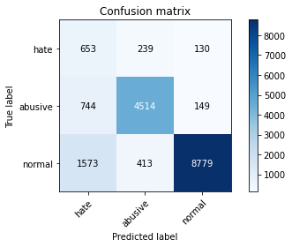

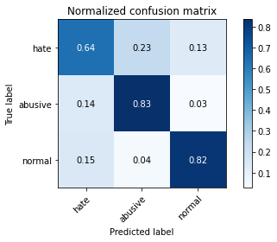

precision recall f1-score support

hate 0.22 0.64 0.33 1022

abusive 0.87 0.83 0.85 5407

normal 0.97 0.82 0.89 10765

accuracy 0.81 17194

macro avg 0.69 0.76 0.69 17194

weighted avg 0.89 0.81 0.84 17194

average eval_loss: 0.7091135176765018, accuracy: 0.8110968942654414

training 6 epoch...

396.0116469860077 seconds used......

6 training finished! average train loss: 0.10239158465072899

total clf loss: 46.07793401204981 total adv loss: 14.369238642117125

evaluating...

Confusion matrix, without normalization

[[ 655 217 150]

[ 785 4463 159]

[1318 418 9029]]

Normalized confusion matrix

[[0.6409002 0.21232877 0.14677104]

[0.14518217 0.8254115 0.02940633]

[0.12243381 0.03882954 0.83873665]]

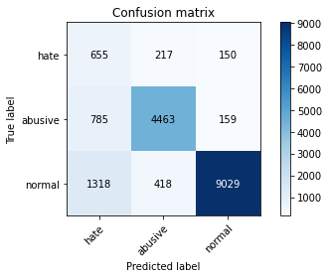

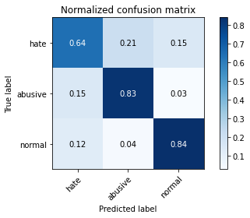

precision recall f1-score support

hate 0.24 0.64 0.35 1022

abusive 0.88 0.83 0.85 5407

normal 0.97 0.84 0.90 10765

accuracy 0.82 17194

macro avg 0.69 0.77 0.70 17194

weighted avg 0.89 0.82 0.85 17194

average eval_loss: 0.7824195329511409, accuracy: 0.8227870187274631

training 7 epoch...

395.98008489608765 seconds used......

7 training finished! average train loss: 0.0838934451375266

total clf loss: 37.78752071177587 total adv loss: 12.454489823547192

evaluating...

Confusion matrix, without normalization

[[ 702 174 146]

[1119 4099 189]

[1418 327 9020]]

Normalized confusion matrix

[[0.68688845 0.1702544 0.14285714]

[0.20695395 0.75809136 0.03495469]

[0.13172318 0.03037622 0.8379006 ]]

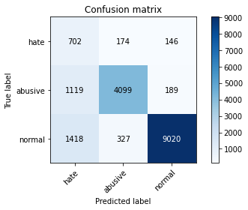

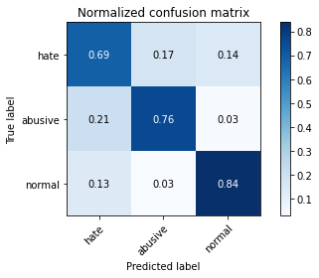

precision recall f1-score support

hate 0.22 0.69 0.33 1022

abusive 0.89 0.76 0.82 5407

normal 0.96 0.84 0.90 10765

accuracy 0.80 17194

macro avg 0.69 0.76 0.68 17194

weighted avg 0.90 0.80 0.84 17194

average eval_loss: 0.9349010765660815, accuracy: 0.8038269163661742

training 8 epoch...

395.82247948646545 seconds used......

8 training finished! average train loss: 0.0729975562120113

total clf loss: 32.8228921451373 total adv loss: 9.699493427371635

evaluating...

Confusion matrix, without normalization

[[ 664 209 149]

[ 814 4431 162]

[1482 420 8863]]

Normalized confusion matrix

[[0.64970646 0.20450098 0.14579256]

[0.15054559 0.81949325 0.02996116]

[0.13766837 0.03901533 0.8233163 ]]

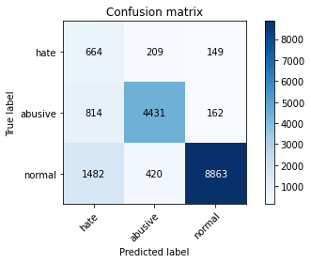

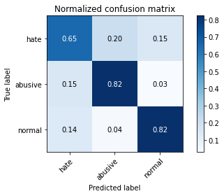

precision recall f1-score support

hate 0.22 0.65 0.33 1022

abusive 0.88 0.82 0.85 5407

normal 0.97 0.82 0.89 10765

accuracy 0.81 17194

macro avg 0.69 0.76 0.69 17194

weighted avg 0.89 0.81 0.84 17194

average eval_loss: 0.8962063255524912, accuracy: 0.8117948121437711

training 9 epoch...

395.15765595436096 seconds used......

9 training finished! average train loss: 0.06467569599300728

total clf loss: 29.162174404365942 total adv loss: 10.216820196903427

evaluating...

Confusion matrix, without normalization

[[ 666 243 113]

[ 822 4446 139]

[1840 554 8371]]

Normalized confusion matrix

[[0.65166341 0.23776908 0.11056751]

[0.15202515 0.82226743 0.02570742]

[0.17092429 0.05146307 0.77761263]]

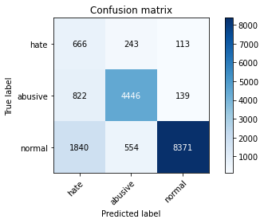

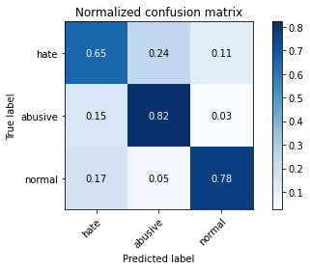

precision recall f1-score support

hate 0.20 0.65 0.31 1022

abusive 0.85 0.82 0.83 5407

normal 0.97 0.78 0.86 10765

accuracy 0.78 17194

macro avg 0.67 0.75 0.67 17194

weighted avg 0.89 0.78 0.82 17194

average eval_loss: 1.0267148263362604, accuracy: 0.7841688961265558

training 10 epoch...

395.2019877433777 seconds used......

10 training finished! average train loss: 0.05583741180188786

total clf loss: 25.06719196535414 total adv loss: 6.624369566919995

evaluating...

Confusion matrix, without normalization

[[ 717 174 131]

[1143 4131 133]

[1878 384 8503]]

Normalized confusion matrix

[[0.70156556 0.1702544 0.12818004]

[0.21139264 0.76400962 0.02459774]

[0.17445425 0.03567116 0.78987459]]

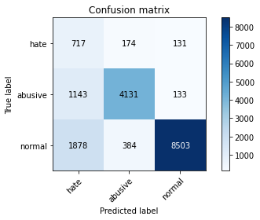

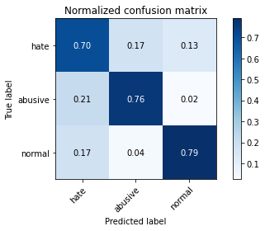

precision recall f1-score support

hate 0.19 0.70 0.30 1022

abusive 0.88 0.76 0.82 5407

normal 0.97 0.79 0.87 10765

accuracy 0.78 17194

macro avg 0.68 0.75 0.66 17194

weighted avg 0.90 0.78 0.82 17194

average eval_loss: 1.1542047953146488, accuracy: 0.7764917994649296

4 run...

training 1 epoch...

394.9490180015564 seconds used......

1 training finished! average train loss: 0.5948833825558626

total clf loss: 270.71502213180065 total adv loss: 143.63367084786296

evaluating...

Confusion matrix, without normalization

[[ 698 157 167]

[ 891 4338 178]

[1097 286 9382]]

Normalized confusion matrix

[[0.68297456 0.15362035 0.16340509]

[0.16478639 0.80229332 0.03292029]

[0.10190432 0.02656758 0.8715281 ]]

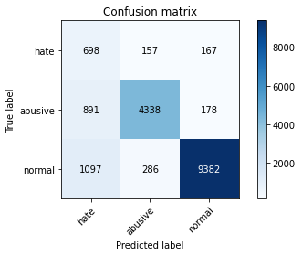

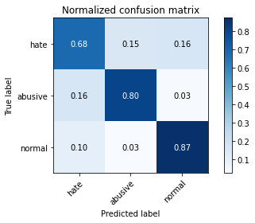

precision recall f1-score support

hate 0.26 0.68 0.38 1022

abusive 0.91 0.80 0.85 5407

normal 0.96 0.87 0.92 10765

accuracy 0.84 17194

macro avg 0.71 0.79 0.71 17194

weighted avg 0.90 0.84 0.86 17194

average eval_loss: 0.4376774260557668, accuracy: 0.8385483308130743

training 2 epoch...

396.4111852645874 seconds used......

2 training finished! average train loss: 0.43413184317455333

total clf loss: 197.19318893551826 total adv loss: 97.45565735921264

evaluating...

Confusion matrix, without normalization

[[ 631 222 169]

[ 643 4614 150]

[1003 310 9452]]

Normalized confusion matrix

[[0.61741683 0.21722114 0.16536204]

[0.11891992 0.85333827 0.02774182]

[0.09317232 0.02879703 0.87803065]]

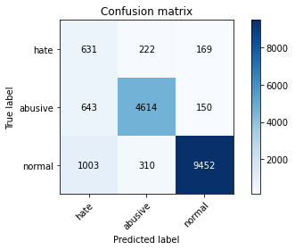

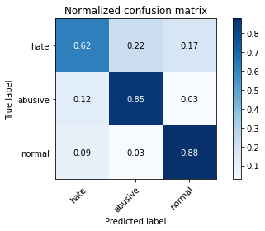

precision recall f1-score support

hate 0.28 0.62 0.38 1022

abusive 0.90 0.85 0.87 5407

normal 0.97 0.88 0.92 10765

accuracy 0.85 17194

macro avg 0.71 0.78 0.73 17194

weighted avg 0.90 0.85 0.87 17194

average eval_loss: 0.4215448472215686, accuracy: 0.8547749214842387

training 3 epoch...

395.18761014938354 seconds used......

3 training finished! average train loss: 0.3196038375556065

total clf loss: 144.8622364923358 total adv loss: 65.5547202732414

evaluating...

Confusion matrix, without normalization

[[ 610 242 170]

[ 616 4625 166]

[1005 369 9391]]

Normalized confusion matrix

[[0.59686888 0.23679061 0.16634051]

[0.11392639 0.85537267 0.03070094]

[0.0933581 0.03427775 0.87236414]]

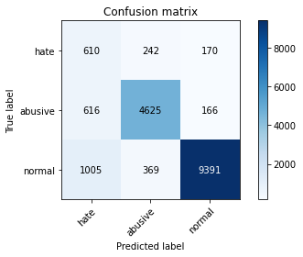

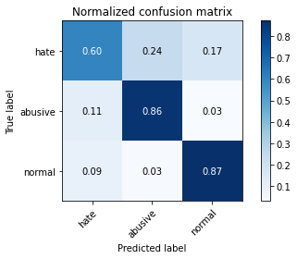

precision recall f1-score support

hate 0.27 0.60 0.38 1022

abusive 0.88 0.86 0.87 5407

normal 0.97 0.87 0.92 10765

accuracy 0.85 17194

macro avg 0.71 0.77 0.72 17194

weighted avg 0.90 0.85 0.87 17194

average eval_loss: 0.4643765356564938, accuracy: 0.8506455740374549

training 4 epoch...

397.75140833854675 seconds used......

4 training finished! average train loss: 0.20841874213758899

total clf loss: 94.16933505609632 total adv loss: 36.796650835778564

evaluating...

Confusion matrix, without normalization

[[ 670 207 145]

[ 939 4310 158]

[1511 333 8921]]

Normalized confusion matrix

[[0.6555773 0.20254403 0.14187867]

[0.17366377 0.79711485 0.02922138]

[0.14036229 0.03093358 0.82870413]]

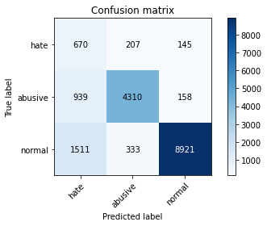

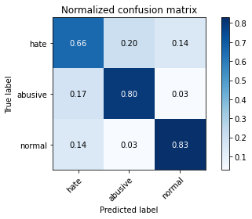

precision recall f1-score support

hate 0.21 0.66 0.32 1022

abusive 0.89 0.80 0.84 5407

normal 0.97 0.83 0.89 10765

accuracy 0.81 17194

macro avg 0.69 0.76 0.69 17194

weighted avg 0.90 0.81 0.84 17194

average eval_loss: 0.6616906003138527, accuracy: 0.8084797022217053

training 5 epoch...

395.1555416584015 seconds used......

5 training finished! average train loss: 0.13499709139693672

total clf loss: 60.92363449279219 total adv loss: 22.398461688688258

evaluating...

Confusion matrix, without normalization

[[ 692 188 142]

[1055 4215 137]

[1569 324 8872]]

Normalized confusion matrix

[[0.67710372 0.18395303 0.13894325]

[0.19511744 0.77954503 0.02533753]

[0.14575012 0.03009754 0.82415235]]

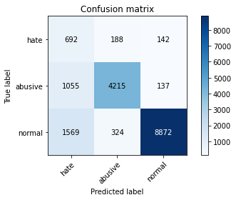

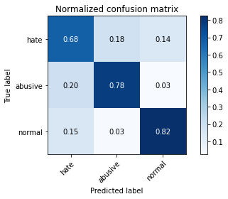

precision recall f1-score support

hate 0.21 0.68 0.32 1022

abusive 0.89 0.78 0.83 5407

normal 0.97 0.82 0.89 10765

accuracy 0.80 17194

macro avg 0.69 0.76 0.68 17194

weighted avg 0.90 0.80 0.84 17194

average eval_loss: 0.7313989099548307, accuracy: 0.8013842037920205

training 6 epoch...

395.1503269672394 seconds used......

6 training finished! average train loss: 0.09853828462675365

total clf loss: 44.30132460151799 total adv loss: 12.97728915438347

evaluating...

Confusion matrix, without normalization

[[ 682 177 163]

[1035 4174 198]

[1269 278 9218]]

Normalized confusion matrix

[[0.66731898 0.17318982 0.15949119]

[0.19141853 0.77196227 0.0366192 ]

[0.11788203 0.02582443 0.85629354]]

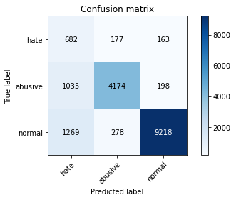

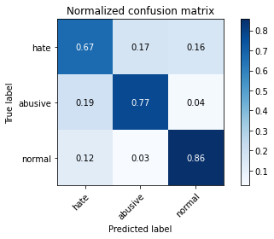

precision recall f1-score support

hate 0.23 0.67 0.34 1022

abusive 0.90 0.77 0.83 5407

normal 0.96 0.86 0.91 10765

accuracy 0.82 17194

macro avg 0.70 0.77 0.69 17194

weighted avg 0.90 0.82 0.85 17194

average eval_loss: 0.79619835746193, accuracy: 0.818541351634291

training 7 epoch...

395.188423871994 seconds used......

7 training finished! average train loss: 0.07850842224223788

total clf loss: 35.38573794486001 total adv loss: 12.130138451655512

evaluating...

Confusion matrix, without normalization

[[ 686 203 133]

[ 939 4342 126]

[1793 368 8604]]

Normalized confusion matrix

[[0.67123288 0.19863014 0.13013699]

[0.17366377 0.80303311 0.02330313]

[0.16655829 0.03418486 0.79925685]]

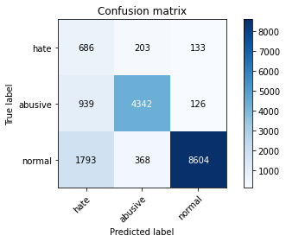

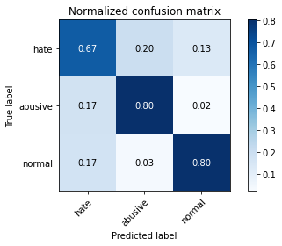

precision recall f1-score support

hate 0.20 0.67 0.31 1022

abusive 0.88 0.80 0.84 5407

normal 0.97 0.80 0.88 10765

accuracy 0.79 17194

macro avg 0.69 0.76 0.68 17194

weighted avg 0.90 0.79 0.83 17194

average eval_loss: 0.960092355471191, accuracy: 0.7928347097824823

training 8 epoch...

395.1758859157562 seconds used......

8 training finished! average train loss: 0.0737664870420864

total clf loss: 33.2588316979236 total adv loss: 11.605557584283815

evaluating...

Confusion matrix, without normalization

[[ 713 199 110]

[ 996 4277 134]

[1922 383 8460]]

Normalized confusion matrix

[[0.69765166 0.19471624 0.10763209]

[0.18420566 0.79101165 0.02478269]

[0.17854157 0.03557826 0.78588017]]

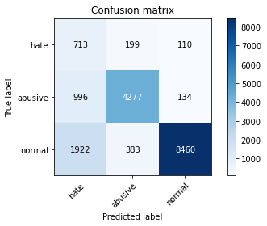

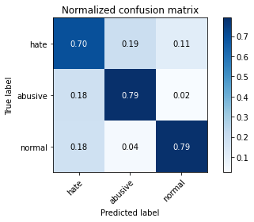

precision recall f1-score support

hate 0.20 0.70 0.31 1022

abusive 0.88 0.79 0.83 5407

normal 0.97 0.79 0.87 10765

accuracy 0.78 17194

macro avg 0.68 0.76 0.67 17194

weighted avg 0.90 0.78 0.82 17194

average eval_loss: 1.045295671741803, accuracy: 0.7822496219611492

training 9 epoch...

395.52814984321594 seconds used......

9 training finished! average train loss: 0.06072350428387119

total clf loss: 27.296881177462637 total adv loss: 7.927377283791429

evaluating...

Confusion matrix, without normalization

[[ 739 150 133]

[1269 3976 162]

[1556 341 8868]]

Normalized confusion matrix

[[0.72309198 0.14677104 0.13013699]

[0.23469576 0.73534307 0.02996116]

[0.1445425 0.03167673 0.82378077]]

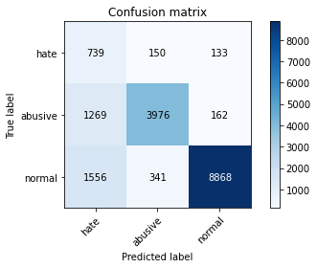

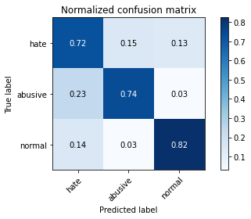

precision recall f1-score support

hate 0.21 0.72 0.32 1022

abusive 0.89 0.74 0.81 5407

normal 0.97 0.82 0.89 10765

accuracy 0.79 17194

macro avg 0.69 0.76 0.67 17194

weighted avg 0.90 0.79 0.83 17194

average eval_loss: 1.0318388542312003, accuracy: 0.7899848784459695

training 10 epoch...

395.89473724365234 seconds used......

10 training finished! average train loss: 0.061525163999664054

total clf loss: 27.685221032530535 total adv loss: 8.591467032609216

evaluating...

Confusion matrix, without normalization

[[ 665 217 140]

[ 831 4416 160]

[1437 419 8909]]

Normalized confusion matrix

[[0.65068493 0.21232877 0.1369863 ]

[0.15368966 0.81671907 0.02959127]

[0.13348816 0.03892243 0.82758941]]

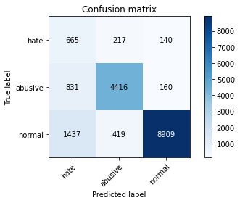

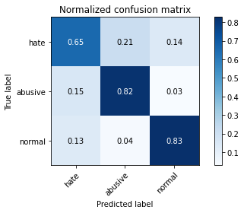

precision recall f1-score support

hate 0.23 0.65 0.34 1022

abusive 0.87 0.82 0.84 5407

normal 0.97 0.83 0.89 10765

accuracy 0.81 17194

macro avg 0.69 0.76 0.69 17194

weighted avg 0.89 0.81 0.84 17194

average eval_loss: 0.8823608631316876, accuracy: 0.8136559264859835

5 run...

training 1 epoch...

395.8340606689453 seconds used......

1 training finished! average train loss: 0.5867400751964233

total clf loss: 267.0437607318163 total adv loss: 142.35815438255668

evaluating...

Confusion matrix, without normalization

[[ 679 222 121]

[ 688 4621 98]

[1495 457 8813]]

Normalized confusion matrix

[[0.66438356 0.21722114 0.1183953 ]

[0.12724246 0.85463288 0.01812465]

[0.13887599 0.04245239 0.81867162]]

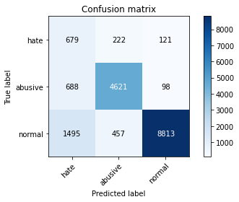

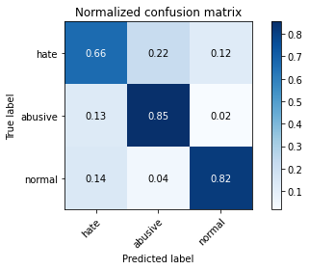

precision recall f1-score support

hate 0.24 0.66 0.35 1022

abusive 0.87 0.85 0.86 5407

normal 0.98 0.82 0.89 10765

accuracy 0.82 17194

macro avg 0.69 0.78 0.70 17194

weighted avg 0.90 0.82 0.85 17194

average eval_loss: 0.5039078569689462, accuracy: 0.8208095847388623

training 2 epoch...

396.1393132209778 seconds used......

2 training finished! average train loss: 0.4303002960929483

total clf loss: 195.37226350605488 total adv loss: 94.98464390821755

evaluating...

Confusion matrix, without normalization

[[ 700 180 142]

[ 893 4401 113]

[1326 374 9065]]

Normalized confusion matrix

[[0.68493151 0.17612524 0.13894325]

[0.16515628 0.81394489 0.02089883]

[0.12317696 0.03474222 0.84208082]]

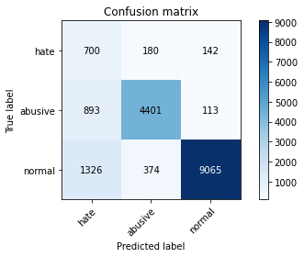

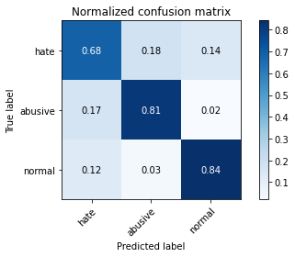

precision recall f1-score support

hate 0.24 0.68 0.36 1022

abusive 0.89 0.81 0.85 5407

normal 0.97 0.84 0.90 10765

accuracy 0.82 17194

macro avg 0.70 0.78 0.70 17194

weighted avg 0.90 0.82 0.85 17194

average eval_loss: 0.4787458118831002, accuracy: 0.8238920553681517

training 3 epoch...

395.8295986652374 seconds used......

3 training finished! average train loss: 0.3178663813670925

total clf loss: 144.1216532662511 total adv loss: 66.13693202007562

evaluating...

Confusion matrix, without normalization

[[ 662 205 155]

[ 796 4472 139]

[1191 397 9177]]

Normalized confusion matrix

[[0.64774951 0.20058708 0.15166341]

[0.14721657 0.82707601 0.02570742]

[0.11063632 0.03687877 0.8524849 ]]

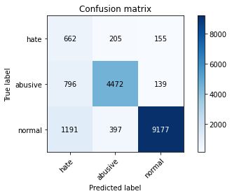

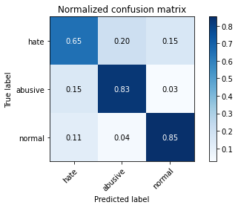

precision recall f1-score support

hate 0.25 0.65 0.36 1022

abusive 0.88 0.83 0.85 5407

normal 0.97 0.85 0.91 10765

accuracy 0.83 17194

macro avg 0.70 0.78 0.71 17194

weighted avg 0.90 0.83 0.86 17194

average eval_loss: 0.4942292582763489, accuracy: 0.8323252297313016

training 4 epoch...

395.6975347995758 seconds used......

4 training finished! average train loss: 0.20799896579328295

total clf loss: 94.00923122279346 total adv loss: 37.31378438510001

evaluating...

Confusion matrix, without normalization

[[ 666 210 146]

[ 848 4410 149]

[1569 308 8888]]

Normalized confusion matrix

[[0.65166341 0.20547945 0.14285714]

[0.15683373 0.8156094 0.02755687]

[0.14575012 0.02861124 0.82563864]]

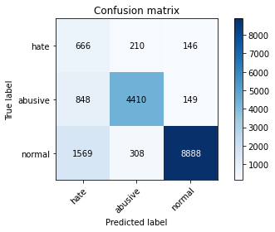

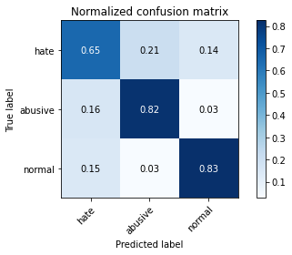

precision recall f1-score support

hate 0.22 0.65 0.32 1022

abusive 0.89 0.82 0.85 5407

normal 0.97 0.83 0.89 10765

accuracy 0.81 17194

macro avg 0.69 0.76 0.69 17194

weighted avg 0.90 0.81 0.85 17194

average eval_loss: 0.6660144579185303, accuracy: 0.8121437710829359

training 5 epoch...

395.8744876384735 seconds used......

5 training finished! average train loss: 0.14287138775907643

total clf loss: 64.38239003531635 total adv loss: 21.807306100148708

evaluating...

Confusion matrix, without normalization

[[ 694 201 127]

[1122 4172 113]

[2079 323 8363]]

Normalized confusion matrix

[[0.67906067 0.19667319 0.12426614]

[0.20750878 0.77159238 0.02089883]

[0.19312587 0.03000464 0.77686948]]

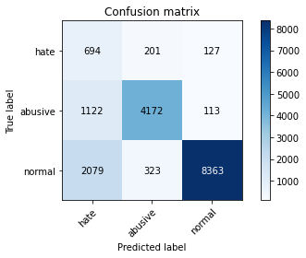

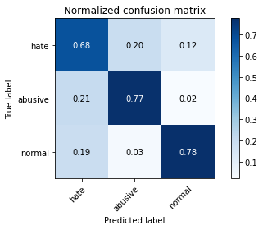

precision recall f1-score support

hate 0.18 0.68 0.28 1022

abusive 0.89 0.77 0.83 5407

normal 0.97 0.78 0.86 10765

accuracy 0.77 17194

macro avg 0.68 0.74 0.66 17194

weighted avg 0.90 0.77 0.82 17194

average eval_loss: 0.8675928313068526, accuracy: 0.7693963010352448

training 6 epoch...

395.84023547172546 seconds used......

6 training finished! average train loss: 0.10566623889448008

total clf loss: 47.60837532579899 total adv loss: 15.964630289949127

evaluating...

Confusion matrix, without normalization

[[ 674 205 143]

[ 907 4371 129]

[1512 456 8797]]

Normalized confusion matrix

[[0.65949119 0.20058708 0.13992172]

[0.16774552 0.80839652 0.02385796]

[0.14045518 0.0423595 0.81718532]]

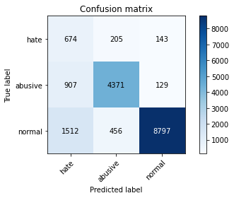

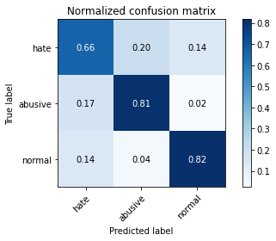

precision recall f1-score support

hate 0.22 0.66 0.33 1022

abusive 0.87 0.81 0.84 5407

normal 0.97 0.82 0.89 10765

accuracy 0.81 17194

macro avg 0.69 0.76 0.68 17194

weighted avg 0.89 0.81 0.84 17194

average eval_loss: 0.8325262790437528, accuracy: 0.8050482726532512

training 7 epoch...

395.85453844070435 seconds used......

7 training finished! average train loss: 0.08584902659489545

total clf loss: 38.59088067431003 total adv loss: 11.195237685999018

evaluating...

Confusion matrix, without normalization

[[ 641 203 178]

[ 930 4298 179]

[1273 309 9183]]

Normalized confusion matrix

[[0.62720157 0.19863014 0.1741683 ]

[0.17199926 0.79489551 0.03310523]

[0.1182536 0.02870413 0.85304227]]

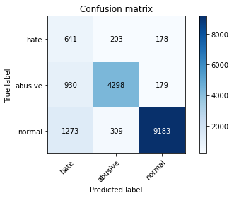

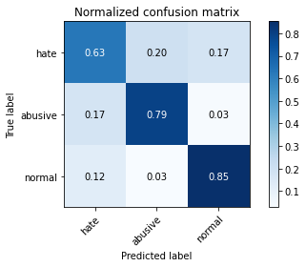

precision recall f1-score support

hate 0.23 0.63 0.33 1022

abusive 0.89 0.79 0.84 5407

normal 0.96 0.85 0.90 10765

accuracy 0.82 17194

macro avg 0.69 0.76 0.69 17194

weighted avg 0.90 0.82 0.85 17194

average eval_loss: 0.818562269679184, accuracy: 0.8213330231476096

training 8 epoch...

395.8490376472473 seconds used......

8 training finished! average train loss: 0.0734449356999858

total clf loss: 32.997775003663264 total adv loss: 9.233369639059674

evaluating...

Confusion matrix, without normalization

[[ 687 181 154]

[1121 4162 124]

[1678 382 8705]]

Normalized confusion matrix

[[0.67221135 0.17710372 0.15068493]

[0.20732384 0.76974293 0.02293323]

[0.15587552 0.03548537 0.80863911]]

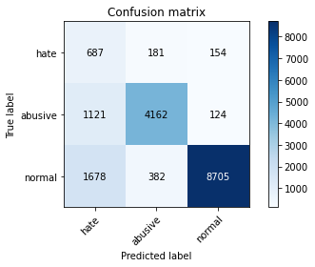

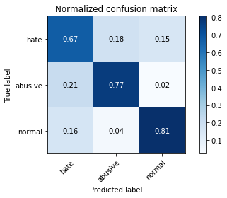

precision recall f1-score support

hate 0.20 0.67 0.30 1022

abusive 0.88 0.77 0.82 5407

normal 0.97 0.81 0.88 10765

accuracy 0.79 17194

macro avg 0.68 0.75 0.67 17194

weighted avg 0.90 0.79 0.83 17194

average eval_loss: 1.0894629425694082, accuracy: 0.7882982435733396

training 9 epoch...

395.5378592014313 seconds used......

9 training finished! average train loss: 0.0689678887302386

total clf loss: 31.126236539217643 total adv loss: 11.469235498025228

evaluating...

Confusion matrix, without normalization

[[ 707 184 131]

[1133 4110 164]

[1834 301 8630]]

Normalized confusion matrix

[[0.69178082 0.18003914 0.12818004]

[0.20954318 0.76012576 0.03033105]

[0.17036693 0.02796098 0.80167209]]

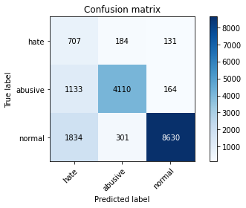

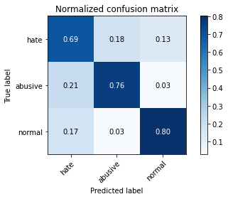

precision recall f1-score support

hate 0.19 0.69 0.30 1022

abusive 0.89 0.76 0.82 5407

normal 0.97 0.80 0.88 10765

accuracy 0.78 17194

macro avg 0.68 0.75 0.67 17194

weighted avg 0.90 0.78 0.83 17194

average eval_loss: 1.0514306462738057, accuracy: 0.7820751424915668

training 10 epoch...

395.76806378364563 seconds used......

10 training finished! average train loss: 0.06483175814570649

total clf loss: 29.146416975243483 total adv loss: 8.518963190794238

evaluating...

Confusion matrix, without normalization

[[ 664 200 158]

[1026 4228 153]

[1468 330 8967]]

Normalized confusion matrix

[[0.64970646 0.19569472 0.15459883]

[0.18975402 0.78194932 0.02829665]

[0.13636786 0.0306549 0.83297724]]

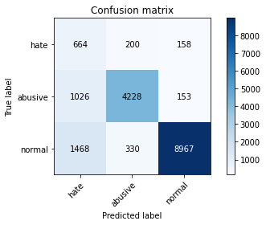

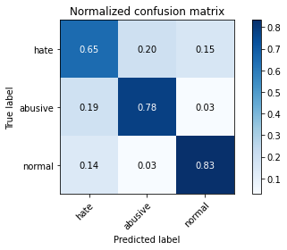

precision recall f1-score support

hate 0.21 0.65 0.32 1022

abusive 0.89 0.78 0.83 5407

normal 0.97 0.83 0.89 10765

accuracy 0.81 17194

macro avg 0.69 0.75 0.68 17194

weighted avg 0.90 0.81 0.84 17194

average eval_loss: 1.0422243598101357, accuracy: 0.8060369896475514

add Codeadd Markdown